Linux User and Group Management

1. Use sudo adduser mark to create a new user named mark. Verify that the user has been created successfully.

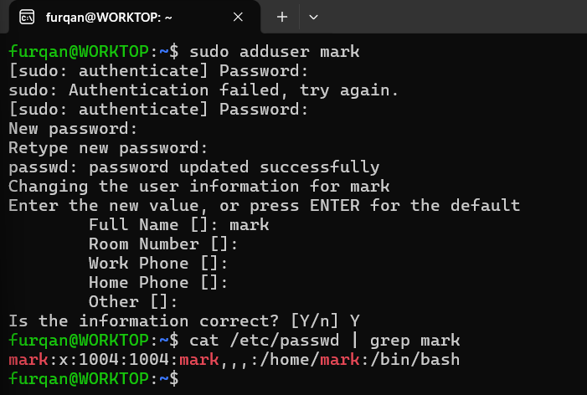

2. Use sudo passwd mark to set or change the password for the mark user. Explain why Linux requires a password for a user account.

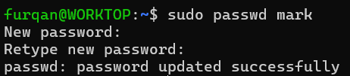

Explanation : Linux requires password for user to provide them security and avoid changes in file system and actions that malfunction the system which helps in providing access control and prevent unauthorized changes.

3. Use cat /etc/passwd to display user account information. Find the entry for mark and explain the meaning of each field in that entry.

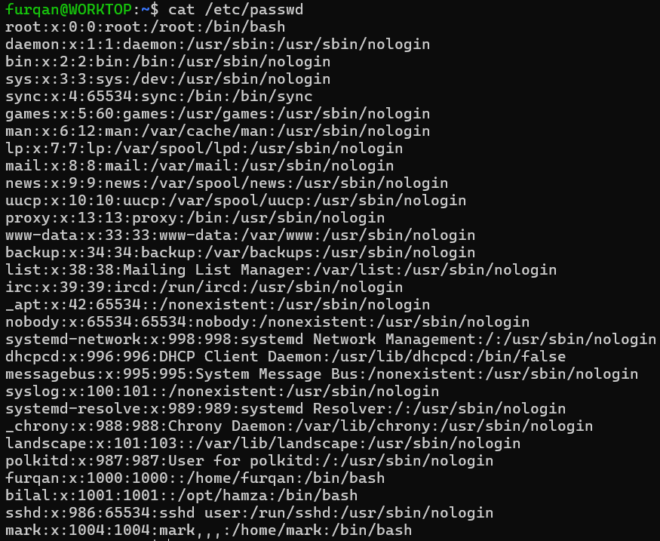

mark:x:1004:1004:mark,,,:/home/mark:/bin/bash

Here , mark is the username , x is the password placeholder , 1004 before is userID and 1004 after is
groupID , mark,,, is the fullname , room number , work phone, home phone separated by commas , Since the other fields are empty thats why there is only comma . /home/mark represents the working directory of mark where the user files are saved , /bin/bash means which command line interface the user is using . In this case the user MARKS is using the bash CLI .

4. Use cat /etc/group to display group information. Identify the groups available on your system and determine which groups the mark user belongs to.

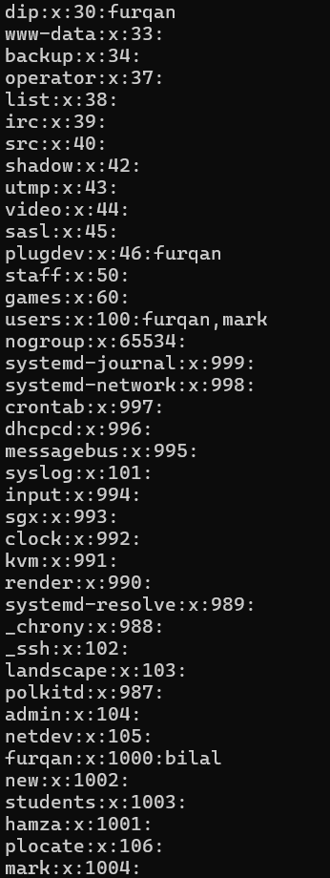

Explanation : When a new user is created in linux it is assigned a default group of its name which is called User-Private Group (UPG) to provide privacy and security . When a new file is created by that user it is only limited to that user and group who created that file . A new user does not have extra privileges than that.

Mark:x:1004:

Here mark is the group name , X represent group password placeholder , 1004 represent the group ID and empty space after colon represents secondary user to that group . Since this group is newly created so it has no secondary users assigned to it thats why its empty.

5. Use cat /etc/hosts to display the contents of the hosts file. Explain the purpose of this file and identify the localhost entries.

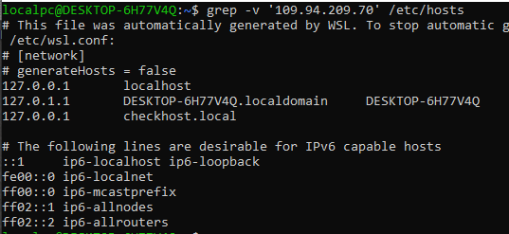

Explanation:
This is a local text-based DNS lookup table — it’s one of the first places your system checks before asking a DNS server to translate a name to an IP address. It Maps hostnames to IP addresses directly, without needing a network DNS server . Entries here override what public DNS says .

127.0.0.1 localhost
ff02::1 ip6-allnodes

These are the localhost Entries. The second one is for the IPv6 .

6. Use sudo cat /etc/shadow to inspect the shadow file. Explain what type of
information it stores and why access to this file is restricted. Do not share or expose password hashes in your screenshots.

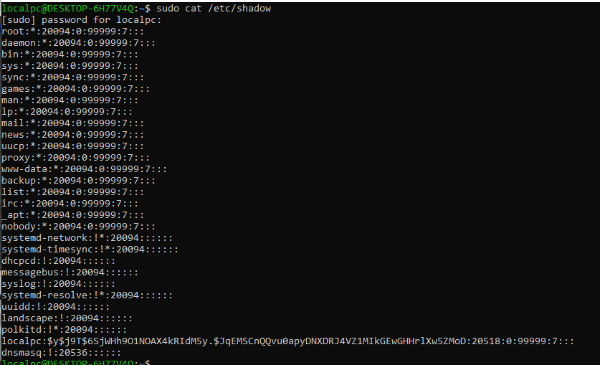

Explanation:
It is the secure password store for Linux/Unix systems. It holds critical authentication data separated from publicly readable account info in /etc/passwd.

There are 9 colon separated fields. The first field shows the username . The second field shows the hashed password . The third field shows the last password changed. The fourth field shows days you must wait before you can change password again .The fifth field shows days after which password must be changed . The sixth field shows days before the expiry user gets a warning . The seventh field shows days after the expiry account gets disabled . The eighth field shows days since epoch when account is permanently disabled . The last ninth field shows reserved — just empty space .

7. Create a test user named student1 using sudo useradd studenti. Then configure a password and verify that the account exists. Explain one difference between useradd and adduser.

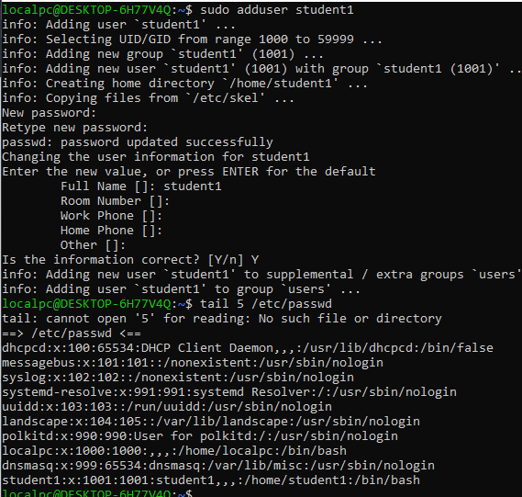

The adduser command is stored at /usr/sbin/adduser and its used in Debian, Ubuntu, Kali, Mint only only while useradd command is stored at /usr/sbin/useradd and its universal means its used everywhere in linux distributions.

8. Use su student1 to switch to the new user. Verify the current username using whoami, then return to your original account. Explain what the su command does.

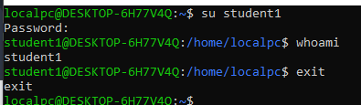

The su command stands for “switch user” used to switch between multiple users.

9. Use sudo su root to switch to the root account. Run whoami to verify the current user, then return to your regular account. Explain why root access should be used carefully.

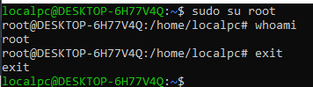

Explanation:
The su root command allows the root user with zero restriction means root can change edit delete files . While it has super user access it should be used carefully because it can delete any file and there is no undo option , A small typo like rm -rf /etc instead of rm -rf ./etc deletes your entire system configuration it won't ask "Delete anyway?" it just does it. Your machine may stop booting entirely. If you stay logged in as root all the time, you'll eventually type a destructive command without thinking and it will work. Regular users get "Permission denied" and are saved; root is not.

10. Use sudo usermod e "MARK" mark to set the comment field for the mark account. Verify the updated information using getent passwd mark or grep "mark:
/etc/passwd.

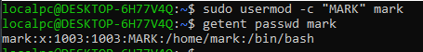

11. Use sudo usermod - 1003 mark to change the UID of mark to 1003, provided that the UID is not already in use. Verify the new UID and explain what a UID represents.

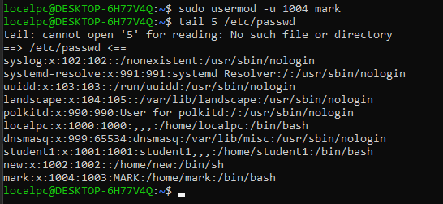

Explanation:
The UID represent the unique ID assigned to every user in linux systems.

12. Use sudo usermod - 2026-10-30 mark to set an account expiration date. Verify the expiration date using sudo chage -1 mark and explain what happens when an account expires.

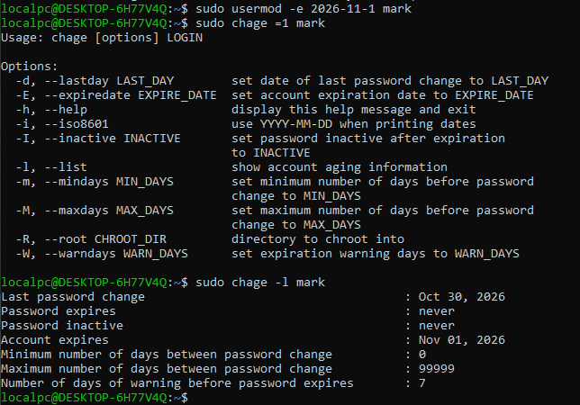

Explanation:
When an account expires it means all its data is deleted and when the user try to login he will be shown “Your account has expired”
13. Use sudo usermod -g sudo mark to change the primary group of mark to audo. Verify the change and explain the difference between a primary group and a supplementary group.

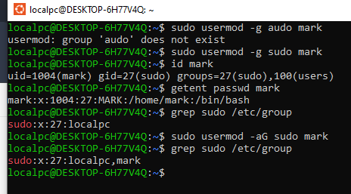

Explanation:
Every user has exactly one primary group ( its default group ). When user creates new files / folder those file are automatically belonged to this group . Primary groups are stord in /etc/passwd . While a user can have many supplementary groups , its stored in /etc/group . it doesnot effect the file creation ownership only what user can access .

14. Use sudo usermod -aG sudo mark to add mark to the supplementary sudo group. Verify the group membership using groups mark or id mark. Explain why -a is generally safer than -G when adding a supplementary group.

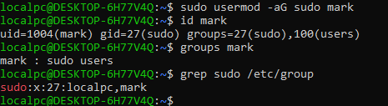

Explanation:
-a is generally safer than -G when adding a supplementary group because without -a if we write sudo usermod -G sudo mark it removes mark from all supplementary groups and just add it to the sudo group while -aG means to append mark to that group which is safer .

15. Practical Challenge: User Lifecycle Management

Perform the following tasks in your Linux lab environment:
• Create a test user named devopauser using sudo adduser devopsuser.
• Set the user's password using sudo passed devopsuser.
• Verify the user entry in /etc/passwd and identify the user's groups. Switch to the new user using su devopauser and verify the username.
• Update the user's comment field using usermod.
• Change the user's UID to an available UID.
• Set an account expiration date.
Add the user to an appropriate supplementary group.
• Delete the test user using sudo deluser devopsuser or sudo userdel devopauser, and verify the result.
Explain what you observed at each stage.

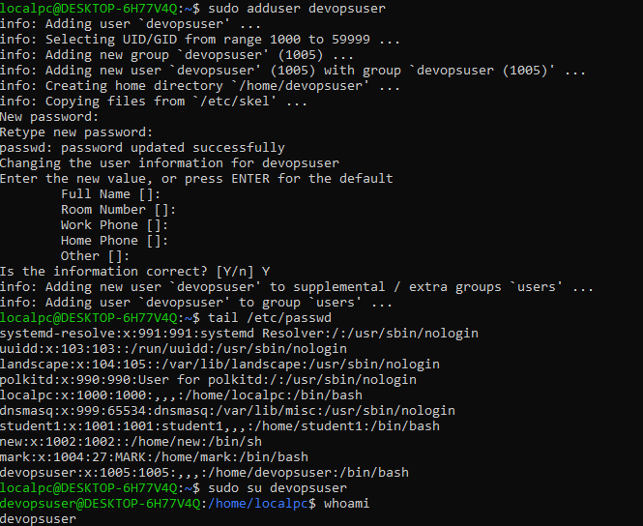
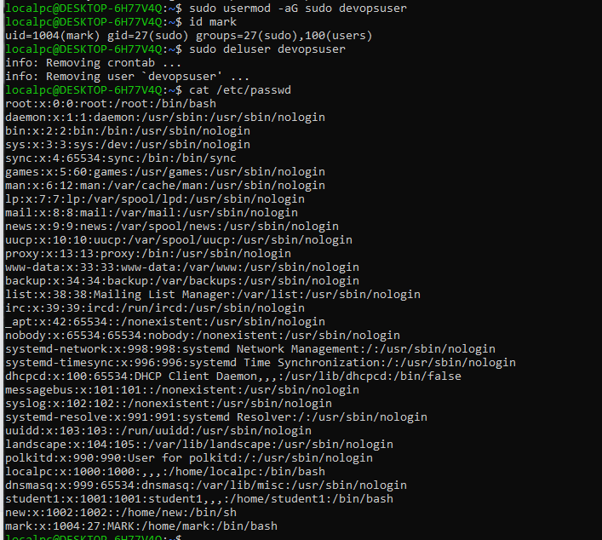
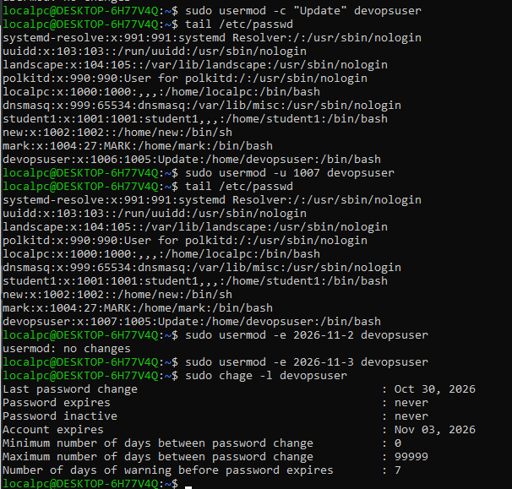

Explanation:

1. Create the test user

Observation: adduser does everything automatically — creates primary group, home folder, copies starter files, sets up skeleton configs, asks for password + details.

2. Set the password

Observation: No output shown while typing (security feature). Matches = success message. /etc/shadow gets updated with the new hashed password for this user.
3. Verify entry + groups + switch user

Observation: New users start in their own primary group (same name as username) — no supplementary groups yet.

4. Update the comment field

Observation: The 5th field changed from previous text to your new string. This is just a descriptive label — does not affect login or permissions.

5. Change the UID to an available one

Observation: UID changed from 1005 → 1010. Files owned by this user automatically update to match the new UID (on most systems). /etc/passwd and /etc/shadow are updated.

6. Set account expiration date

Observation: Account will be completely disabled on that date. User gets "account expired" message — cannot log in at all. Different from password expiry (which lets user set a new one).

7. Add to a supplementary group

Observation: -aG adds without removing existing groups. New groups appear in the list after the primary group. /etc/group now lists devopsuser as a member.

8. Delete the test user

Observation: User entry removed from /etc/passwd, /etc/shadow, /etc/group. Home folder deleted.

